Project Design Phase
Solution Architecture – DocSpot (Doctor Appointment Booking App)

Project Name | DocSpot – Doctor Appointment Booking System
Maximum Marks | 4 Marks

Solution Architecture
The Solution Architecture of DocSpot is designed to ensure a secure, scalable, and user-friendly doctor appointment booking platform. It focuses on efficient data flow, role-based access, real-time scheduling, and seamless interaction between patients, doctors, and the admin.
The architecture follows the MERN Stack (MongoDB, Express.js, React, Node.js) and adopts a modular, layered design.

Key Highlights of the Solution Architecture
1. Scalable Client–Server Architecture
DocSpot uses a React-based frontend that communicates with the backend through REST APIs.
The client handles UI rendering, routing, and user interaction, while the server manages all business logic.

2. Robust Authentication & Authorization
- JWT-based Authentication ensures secure sessions.
- Role-Based Access Control (RBAC) differentiates patients, doctors, and admins.
- Sensitive API routes are protected via middleware.

3. Centralized Database Management
- MongoDB stores users, doctors, appointments, and medical records.
- Mongoose provides schema validation & relationships.
- Data is stored in separate collections to ensure scalability and reduce load.

4. Unified Appointment Scheduling
The system includes:
- Real-time doctor availability
- Appointment booking with date/time slots
- Document upload support
- Automatic booking confirmation & reminders

5. Doctor Management Workflow
Doctors have:
- A personal dashboard
- Schedule management tools
- Appointment lists
- Patient record access
- Approval system (controlled by Admin)

6. Admin Panel for Monitoring
Admins can:
- Approve/reject doctor registrations
- Monitor user activity
- View system statistics
- Manage disputes and user reports

7. Secure Data Handling
- Passwords are hashed using bcrypt
- JWT protects routes
- Multer handles secure document uploads
- Database backups ensure data safety

Solution Architecture Diagram (Example)
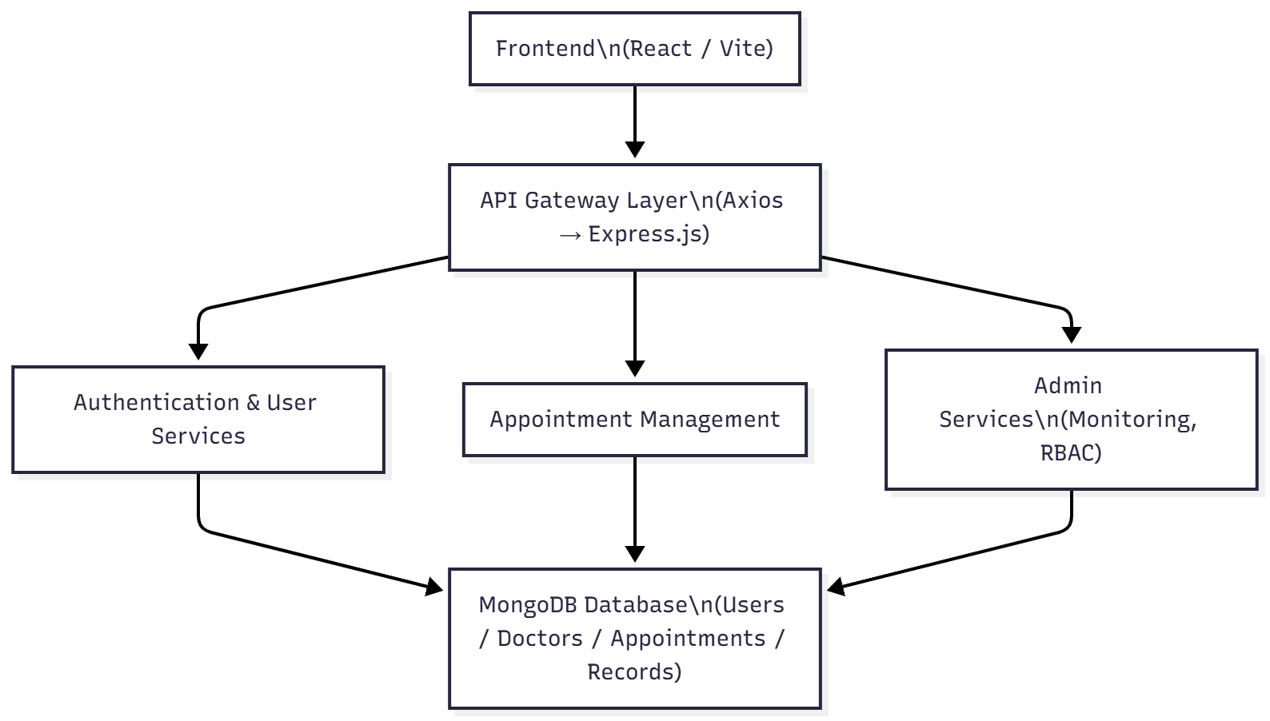

System Components Overview
Frontend (React + Tailwind CSS)
- Patient dashboard
- Doctor dashboard
- Admin panel
- Appointment booking UI
- Notifications

Backend (Node.js + Express.js)
- MVC architecture
- Business logic controllers
- Middleware for authentication
- Role-based route protection

Database Layer (MongoDB + Mongoose)
- Schemas: Users, Doctors, Appointments
- References: userID, doctorInfo, userInfo
- Fast CRUD operations
- Scalable, NoSQL-based structure

End-to-End Workflow
Patient Workflow
- Register/Login
- Browse doctors
- Filter by specialization
- Choose doctor → select date/time
- Upload records
- Book appointment → get confirmation
Doctor Workflow
- Login as doctor
- Await admin approval
- Manage profile & availability
- View appointments
- Update status
Admin Workflow
- Login
- Verify doctors
- Manage users
- Resolve disputes
- View system analytics

